Boy Scout Word Ladder
(February 8th is National Boy Scout Day !)
Start with “boy” another name for a young man.
Boy Change 1 letter to make a word that means shy or reserved.
Coy Change 1 letter to make a word that means a feeling of great pleasure or happiness.
Joy Change 1 letter to make an object that a child would like to play with.
Toy Change 1 letter to make another word for a young child.
Tot Change 1 letter to make a container in which you would boil water or heat soup.
Pot Add 1 letter to make a round mark or stain that is often on clothes and can be made from mud, blood, or ink.
Spot Add a vowel to make a pipe or tube through which a liquid is poured.
Spout Change the “p” to another letter and add a letter to the end to make a word that goes with the first word and that is a worldwide organization for boys (and more recently girls)
Scouts!
Happy National Boy Scout Day!!! (February 8)
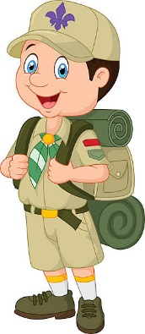

Find out more information about Scouting at https://www.britannica.com/topic/Boy-Scouts

Here’s a great source for Scouting songs you can teach and share with your students.
http://www.boyscouttrail.com/songs.asp

Find more resources for word study and fluency at http://timrasinski.com/products.html

Also see: Rasinski, T. Daily Word Ladders (Grades K-1, 1-2, 2-4, and 4-6). Scholastic.

Rasinski, T. Vocabulary Ladders (Grades 2, 3, 4, 5, 6). Go to www.timrasinski.com - click on Products.

