December. A Word Ladder for Pearl Harbor Day – December 7th.

Start with the word “Harbor” – a place of safety, usually for ships and boats.

Harbor Take away 1 letter to make a shelter made of tree branches and vines. A special day that uses this word honors the planting of trees.
Arbor Take away the “b” and rearrange the remaining letters to make the sound made by a lion.
Roar Change 1 letter to make the back end of something.
Rear Change 1 letter make the name of animal that growls and hibernates in the winter.
Bear Change 1 letter to make a fruit with pale green or brownish skin, a firm juicy flesh, and an oblong shape in which a broad base end tapers upward to a narrow stem end. At Christmas we sing a song that includes a partridge bird in a tree that grows this fruit.
Pear Add 1 letter to make a word that goes with the first word and describes a naval base in Hawaii that was attacked on Dec 7, 1941 to begin the United States’ involvement in World War II.
Pearl
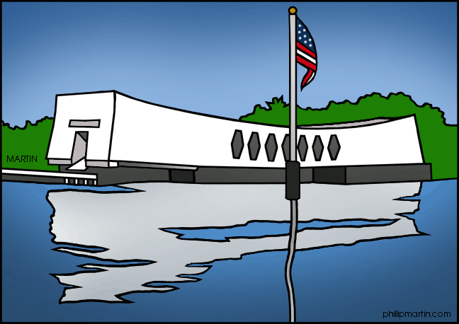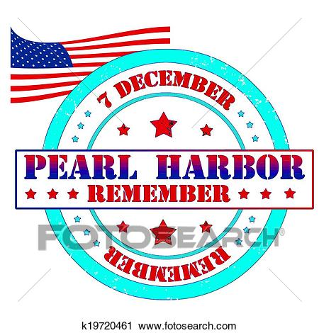

For more see: Rasinski, T.: Daily Word Ladders, K-1, 1-2, 2-4. 4-6
Vocabulary Ladders, 1, 2, 3, 4, 5, 6

